## G H RAISONI COLLEGE OF ENGINEERING & MANAGEMENT, WAGHOLI, PUNE

**(An Autonomous Institute under UGC Act 1956 & Affiliated to Savitribai Phule Pune University)**

**EXPERIMENT NO. 3**

# AIM OF EXPERIMENT: Perform the Histogram Analysis of given dataset using Data Analysis Toolbox of Excel

**Date of Performance:** 12/03/2020 **Sign of Teacher:**

**Name: Swayam Terode Roll No. : C70**

**Division: C**

**AIM:** Perform the Histogram Analysis of given dataset using Data Analysis Toolbox of Excel

## What Is a Histogram?

A histogram is a graphical representation that organizes a group of data points into user-specified ranges. Similar in appearance to a bar graph, the histogram condenses a data series into an easily interpreted visual by taking many data points and grouping them into logical ranges or bins.

**What is the purpose of Histogram?**

The purpose of a histogram (Chambers) is to graphically summarize the **distribution** of a univariate data set.

**PRODECEDURE:**

**Step 1:** First download any excel file having numeric and other data **INPUT**

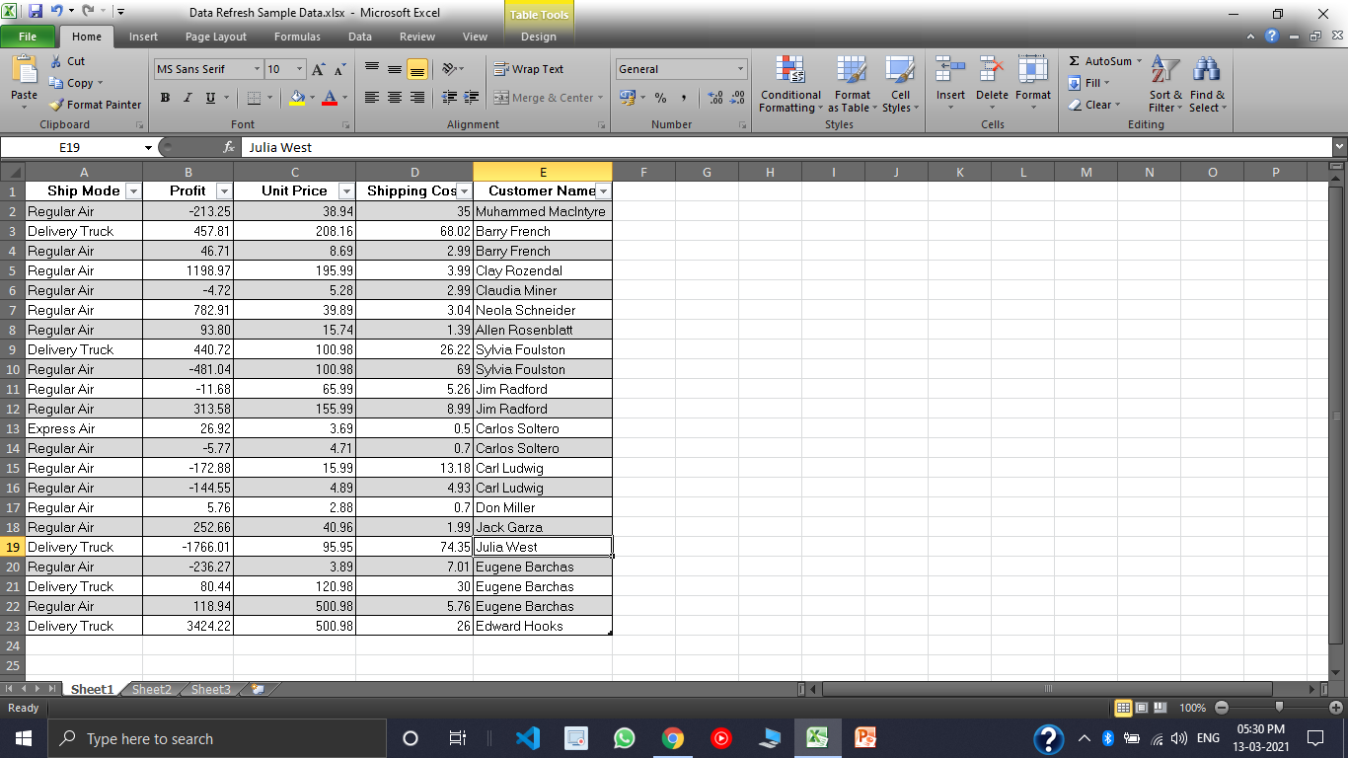

**Step 2:** Rows and column should not be empty.

**Step 3:** Then select **Data Analysis** from the **DATA Tab** and then Select **Histogram** and then click on **OK.**

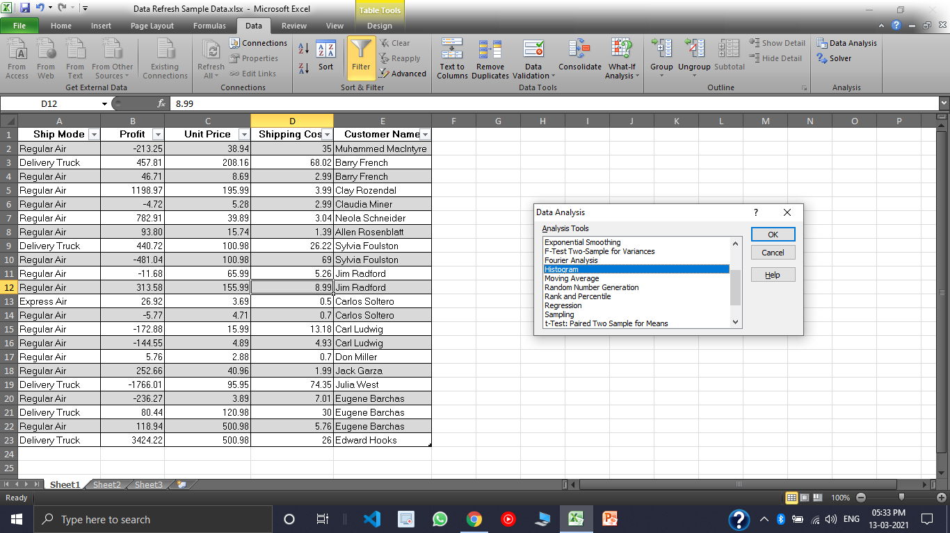

**Step 4:** Select the **Input Range**, remember that the input Range should not be empty.

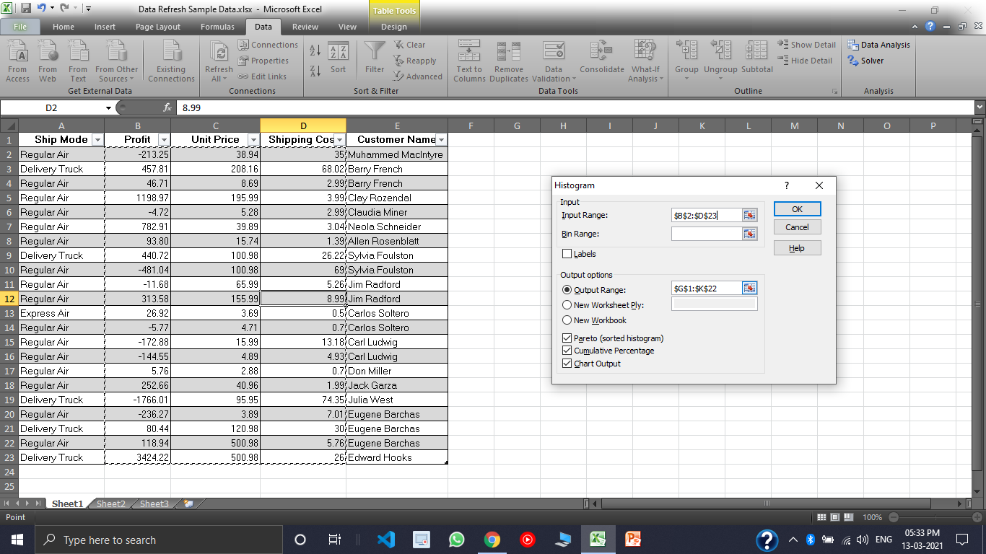

**Step 5:** When you are done with selecting the range select give a proper Output Range, also select the Pareto (sorted histogram), Cumulative Percentage and Chart Output.



**RESULT:**

